Shropshire Primary Schools Half Marathon Race Day information.

Date and Start time

Saturday April 25th at 9am.

Venue

West Mid Showground
Gravel Hill Lane
Shrewsbury
SY1 2PF

Event Information

The event will be set up as per the map below.

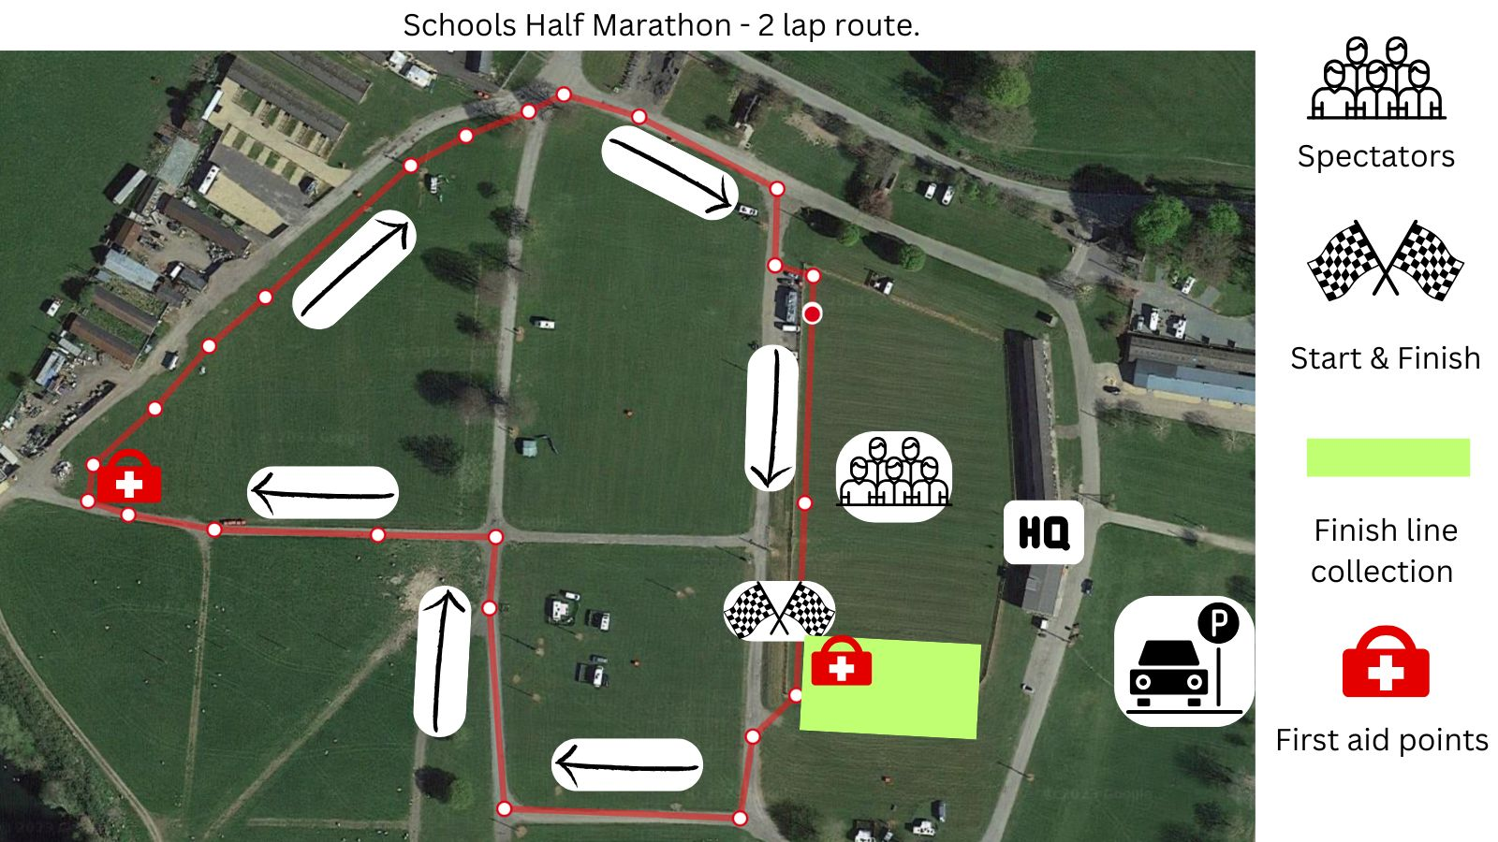

The event will open from 8am.

The children will run the above loop twice. This enables you to see your children more than once to cheer them on. When crossing the finish, the children will turn left into a barriered finish line collection point where they collect their medal and drink.

In the collection point there will be pens marked in batches of numbers from 0 - 200, 201 – 400 and so on. Please explain to your child(ren) that when they finish and have collected their medal and drink, to look for the numbered signage and go to the pen that matches their bib number to meet you. There will be Teacher volunteers from the represented schools in the finish area helping guide the children to their numbered pens to meet you.

You will need to enter the finish area by showing your wristband to a marshal, please can only one adult wearing the wristband enter the finish line collection point and any other family and friends wait outside of the finish area. Please note we have a separate entry and exit into and out of the finish area.

The children’s runs will be started in year groups. They will be called forward by the commentator to make their way to the start line at the following times.

Year | Arrive by | Called forward time | Start time
Reception | 08:30 | 09:00 | 09:05
1 & 2 | 09:00 | 09:30 | 09:35
3 & 4 | 09:30 | 10:00 | 10:05
5 & 6 & Severndale | 10:00 | 10:30 | 10:35

We have over 1800 children signed up to participate from 37 schools from across Shropshire. Please arrive early as there will be queues to get into the showground.

Bibs, wristbands, and t-shirts

Please can children wear their t-shirt with bib number pinned to the front and parents please wear the matching numbered wristband. Please write your name and mobile number on the back of the bib number.

Medical
We will have our medical team from St Johns Ambulance at the event who will be situated at the finish line and halfway around the run loop. If your children have any medical needs St Johns may need to know about then please write them on the back of the bib.

Parking
Parking is available at the West Mid Showground. There is a £3 charge which goes directly to the Showground Charity. Please have £3 in change ready for when you arrive.
There are also several car parks in in the Town Centre which are within a 15-minute walk.

